Department of
Artificial Intelligence and Machine Learning
B.Tech III Semester Academic Year 2026-2027
Data Base Management Systems (2501IT05)
Capstone Project Documentation


ADITYA UNIVERSITY
Surampalem, Kakinada District Andhra Pradesh-533437


SCHOOL OF COMPUTING
Department of Artificial Intelligence and Machine Learning
ONLINE SHOPPING DATABASE SYSTEM
A Capstone Project Report
BATCH NUMBER : 4
Submitted in partial fulfillment of the requirements for the award of the degree of
BACHELOR OF TECHNOLOGY
in
ARTIFICIAL INTELLIGENCE AND MACHINE LEARNING
Submitted by
P KRISHNA KUMARI - AIML | (25B11AI863)
P MADHU SHALINI - AIML | (25B11AI957)
S TEJASWINI - AIML | (25B11AIB52)
T DEVI PHANITHA - AIML | (25B11AIB84)
Under the guidance of
Dr. P. Kishorekumar, PhD.
Associate Professor, Department of AIML
ADITYA UNIVERSITY, SURAMPALEM
Academic Year: 2026 - 2027
SCHOOL OF COMPUTING
Department of Artificial Intelligence and Machine Learning
CERTIFICATE
This is to certify that the Cornerstone project work entitled "ONLINE SHOPPING DATABASE SYSTEM" is submitted by
P KRISHNA KUMARI - AIML | (25B11AI863)
P MADHU SHALINI - AIML | (25B11AI957)
S TEJASWINI- AIML | (25B11AIB52)
T DEVI PHANITHA - AIML | (25B11AIB84)

In partial fulfillment of the requirements for the award of the B.Tech. degree in Artificial Intelligence and Machine Learning for the academic year 2026-2027.

Project Guide  Dr. P. Kishorekumar, PhD.  Associate Professor, Department of AIML | Head of the Department:  Dr. Kovvuri N Bhargavi  Associate Professor & HOD

DECLARATION
We hereby declare that the Cornerstone project entitled "ONLINE SHOPPING DATABASE SYSTEM" is original and is submitted to ADITYA UNIVERSITY, Surampalem, in partial fulfillment of the requirements for the award of the B.Tech. Degree in Artificial Intelligence and Machine Learning. We further declare that this project work has not been submitted, either in full or in part, for the award of any degree in this or any other institution. We also confirm that this work complies with the Institutional Academic Integrity and AI Usage Policy.
Place: Surampalem
Date:
By

P KRISHNA KUMARI - AIML | (25B11AI863)
P MADHU SHALINI - AIML | (25B11AI957)
S TEJASWINI- AIML | (25B11AIB52)
T DEVI PHANITHA - AIML | (25B11AIB84)

ACKNOWLEDGEMENT
It is with immense pleasure that we express our sincere gratitude to our Cornerstone Project Guide, Dr. P. Kishorekumar, PhD. Associate Professor, Department of AIML, who has guided us throughout the project. His valuable support, encouragement, and guidance have greatly contributed to the successful completion of this work.
We would like to thank our Deputy Heads of the Department, Dr. B. Manikyala Rao, Associate Professor, Dr. R. Suneetha, Assistant Professor and Dr. D. Veeraswamy, Assistant Professor for their support and valuable suggestions.
Our deepest thanks to our Head of the Department Dr. K. Naga Bhargavi, Associate Professor & HOD, for her inspiration and for providing all the necessary facilities and resources required for this project.
We also extend our sincere thanks to Dr. M.V. Rajesh, Associate Dean, School of Computing for their encouragement and support during the course of our project.
We would like to express our sincere gratitude to Dr. G. Suresh, Registrar, Dr. A. Ramesh, Pro Vice-Chancellor (Engineering & Sciences), Dr. S. Rama Sree, Pro Vice-Chancellor (Academics), Dr. M.B. Srinivas, Vice-Chancellor, Dr. M. Sreenivasa Reddy, Deputy Pro Chancellor and Management, Aditya University for providing excellent infrastructure and state-of-the-art laboratories.
Finally, we would like to thank the faculty members, lab technicians, non-teaching staff, and our friends who have directly or indirectly supported us in completing this Cornerstone project successfully.
By
P KRISHNA KUMARI - AIML | (25B11AI863)
P MADHU SHALINI - AIML | (25B11AI957)
S TEJASWINI - AIML | (25B11AIB52)
T DEVI PHANITHA - AIML | (25B11AIB84)

TABLE OF CONTENTS
1. Cover Page 1
2. Certificate 2
3. Declaration 3
4. Acknowledgement 4
5. Abstract 7
6. List of Figures / List of Tables / Acronyms 8
7. List of Tables 9
8. Acronyms 10
9. Introduction 11-12
10. System Analysis 13-14
11. Database Design 15
12. ER Diagram 16-17
13. Relational Schema 18
14. Table Design 19-20
15. Normalization 21
16. SQL Implementation 22-23
17. SQL Queries & Screenshots 25-41
18. Conclusion & Future Enhancements 42-43
19. References 44

ABSTRACT
The Online Shopping System is a database-based application designed to manage the major activities involved in an online shopping platform. The system provides a structured way to store and manage information related to customers, products, categories, addresses, shopping carts, orders, payments, shipments, and product reviews.
The database acts as a centralized storage system where related information can be efficiently maintained and retrieved. Primary keys and foreign keys are used to establish relationships between entities and maintain referential integrity.
The proposed system addresses common problems such as data fragmentation, inconsistent records, inventory inaccuracies, slow order processing, and difficulties in managing customer and order information.
The database design includes entities such as Customer, Category, Product, Address, Orders, Cart, Payment, Shipment, and Review. The system supports operations such as customer management, product management, cart management, order processing, payment recording, shipment tracking, and review management.
Normalization is used to reduce data redundancy and update anomalies. SQL can be used to perform data definition, insertion, retrieval, updating, deletion, joining, aggregation, and reporting operations.
The proposed system provides a structured database foundation for an online shopping application and can be further extended with advanced features such as inventory management, recommendation systems, discount management, multiple payment gateways, and analytics dashboards.

LIST OF FIGURES
Figure 1. Online Shopping System Database Architecture
Figure 2. Entity Relationship Diagram of Online Shopping System
Figure 3. Relational Schema of Online Shopping System
Figure 4. Customer Management / Customer Records
Figure 5. Product and Category Records
Figure 6. Shopping Cart Records
Figure 7. Order Details
Figure 8. Payment Details
Figure 9. Shipment Details
Figure 10. Customer Product Reviews
Figure 11. SQL Query Output – Customer and Orders
Figure 12. SQL Query Output – Product and Category
Figure 13. SQL Query Output – Order and Payment
Figure 14. SQL Query Output – Shipment Tracking

LIST OF TABLES
Table 1. Major Database Entities
Table 2. Customer Table Structure
Table 3. Category Table Structure
Table 4. Product Table Structure
Table 5. Address Table Structure
Table 6. Orders Table Structure
Table 7. Cart Table Structure
Table 8. Payment Table Structure
Table 9. Shipment Table Structure
Table 10. Review Table Structure
Table 11. Keys and Constraints
Table 12. Sample Data Records
Table 13. Normalization Process

ACRONYMS
ACRONYMS
- DBMS – Database Management System
- ER – Entity Relationship
- SQL – Structured Query Language
- DDL – Data Definition Language
- DML – Data Manipulation Language
- DQL – Data Query Language
- DCL – Data Control Language
- TCL – Transaction Control Language
- PK – Primary Key
- FK – Foreign Key
- 1NF – First Normal Form
- 2NF – Second Normal Form
- 3NF – Third Normal Form
- ACID – Atomicity, Consistency, Isolation, Durability
- SKU – Stock Keeping Unit
- UI – User Interface
- CRUD – Create, Read, Update, Delete

1. INTRODUCTION
1.1 Brief Information About the Project
An Online Shopping System is a database-oriented application that enables customers to browse products, manage shopping carts, place orders, make payments, and track shipments.
The system stores information about customers, products, categories, addresses, orders, payments, shipments, carts, and reviews in a centralized relational database.
From a DBMS perspective, the system contains multiple interconnected entities. Relationships between these entities are maintained using primary keys and foreign keys.
The system is designed to provide organized data storage, efficient retrieval, data consistency, and proper relationship management.

1.2 Motivation and Contribution of Project

Online shopping platforms handle large amounts of customer, product, order, payment, and shipment information.

If this information is maintained manually or in disconnected files, problems such as duplicate records, inconsistent information, inventory errors, and difficulty in retrieving order details may occur.

The project is motivated by the need to provide a structured database solution for managing these activities.
Major contributions of the project:
- Centralized storage of shopping-related information.
- Management of customer information.
- Management of products and categories.
- Management of customer addresses.
- Shopping cart management.
- Order management.
- Payment information management.
- Shipment tracking.
- Product review management.
- Maintenance of relationships using primary and foreign keys.
- Reduction of redundant data through normalization.

1.3 Objectives of the Project

The main objectives of the Online Shopping System are:

To design a structured relational database for an online shopping platform.

To manage customer information efficiently.

To store and manage product and category details.

To maintain multiple customer addresses.

To manage shopping cart items.

To record customer orders.

To maintain payment details associated with orders.

To maintain shipment and delivery information.

To allow customers to provide product reviews.

To maintain data integrity using primary and foreign keys.

To reduce data redundancy through normalization.

To support efficient SQL queries and reporting.

1.4 Scope of the Project
The scope of the Online Shopping System covers the database-oriented management of an e-commerce platform, including customer, category, product, address, shopping cart, order, payment, shipment, and review information. The system is designed to provide a structured database for managing customer details, products and categories, shopping carts, orders, payments, deliveries, and product reviews. The database is developed to support efficient data storage, retrieval, updating, and SQL-based reporting. The system can be extended in the future to include features such as inventory management, discount and coupon management, wishlist management, seller management, product recommendations, returns and refunds, and analytics.
2. SYSTEM ANALYSIS

2.1 Existing System

In a basic or poorly integrated online shopping environment, customer, product, order, payment, and shipment information may be stored in separate files or systems.

The major problems include:

Data fragmentation.

Duplicate customer or product records.

Inconsistent information.

Difficulty in maintaining product stock.

Manual order processing.

Difficulty in tracking orders.

Difficulty in retrieving customer purchase history.

Difficulty in generating reports.

Increased possibility of data-entry errors.
2.2 Proposed System
The proposed system uses a centralized relational database to manage the information required for an online shopping platform . The database organizes information into related tables:
- Customer
- Category
- Product
- Address
- Orders
- Cart
- Payment
- Shipment
- Review
Primary keys uniquely identify records, while foreign keys connect related tables.

2.3 Functional Requirements
Module | Functional Requirement
Customer Management | Add, update, search and display customer details.
Category Management | Store and maintain product categories.
Product Management | Store product details, price, brand and stock information.
Address Management | Store multiple addresses associated with customers.
Cart Management | Add products to carts and maintain quantities.
Order Management | Create and maintain customer orders.
Payment Management | Store payment method, amount and transaction details.
Shipment Management | Maintain courier, tracking and delivery information.
Review Management | Store customer ratings and reviews for products.
Search and Reporting | Retrieve information using SQL queries.

2.4 Non-Functional Requirements
- Performance –The database should return results efficiently for normal shopping operations.
- Integrity – Primary keys and foreign keys should prevent invalid relationships and duplicate identifiers.
- Security – Customer and payment-related information should be protected through suitable access controls.
- Usability – The database application should provide understandable interfaces and reports.
- Reliability – Transactions should maintain a consistent database state.
- Scalability – The database should support increasing numbers of customers, products, orders, and transactions.

2.5 Requirements Specification
Category | Suggested Requirement
Hardware | Processor: Intel i3 or above  RAM: Minimum 4 GB  Storage: Adequate storage for database and project files  Standard keyboard and mouse  Monitor/display
Software | Operating System: Windows 10/11 or equivalent  Relational DBMS: MySQL used for implementation  SQL development environment  Database management interface

3. DATABASE DESIGN

3.1 Major Entities
Entity | Description
Customer | Stores customer information.
Category | Groups similar products.
Product | Stores information about products sold online.
Address | Stores customer delivery addresses.
Orders | Records customer purchases.
Cart | Stores products selected by customers before purchase.
Payment | Records payment information for an order.
Shipment | Stores order delivery and tracking information.
Review | Stores customer feedback and ratings for products.

3.2 Database Design Approach

The database design follows a relational approach.Each major entity is represented as a separate relation/table .The tables are connected through foreign keys.

For example:

Customer → Orders A customer can place multiple orders.

Category → Product A category can contain multiple products.

Orders → Payment An order is associated with payment information.

Orders → Shipment An order is associated with shipment information.

3.3 Relationships
Relationship | Cardinality | Meaning
Customer → Address | 1 : M | One customer can have many addresses.
Customer → Orders | 1 : M | One customer can place many orders.
Address → Orders | 1 : M | One address can be used for many orders.
Category → Product | 1 : M | One category can contain many products.
Orders → Payment | 1 : 1 | One order has one payment.
Orders → Shipment | 1 : 1 | One order has one shipment.
Customer → Review | 1 : M | One customer can write many reviews.
Product → Review | 1 : M | One product can have many reviews.
Customer → Cart | 1 : M | One customer can have many cart items.
Product → Cart | 1 : M | One product can be added to many carts.

4. ER DIAGRAM

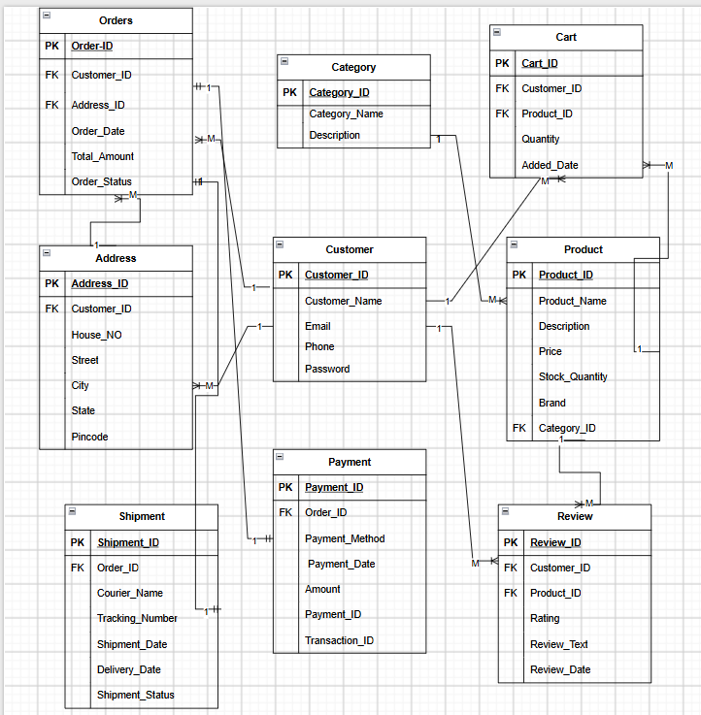

Figure 1: ER Diagram of Online Shopping System
The ER diagram summarizes the entity structure and cardinalities described in the supplied DBMS project material. It is a documentation-level representation; the final project team should align attribute names and cardinalities with the actual implemented database.

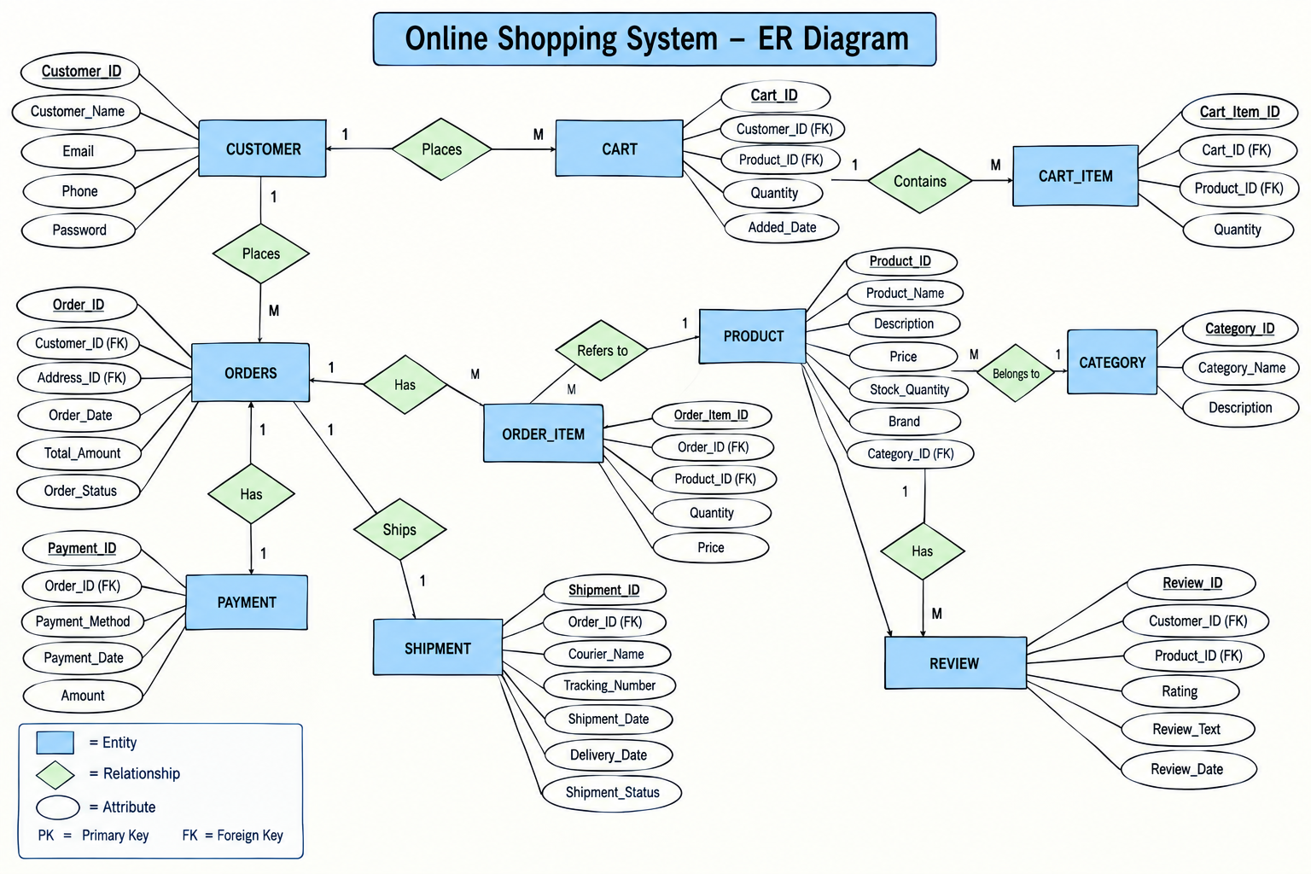

Figure 2: ER Diagram of the Online Shopping Database System (MANUAL)

5. RELATIONAL SCHEMA
Relation | Relational Schema
CUSTOMER | Customer_ID, Customer_Name, Email, Phone, Password  PK: Customer_ID
CATEGORY | Category_ID, Category_Name, Description  PK: Category_ID
PRODUCT | Product_ID, Product_Name, Description, Price, Stock_Quantity, Brand, Category_ID  PK: Product_ID , FK: Category_ID
ADDRESS | Address_ID, Customer_ID, House_No, Street, City, State, Pincode  PK: Address_ID , FK: Customer_ID
ORDERS | Order_ID, Customer_ID, Address_ID, Order_Date, Total_Amount, Order_Status  PK: Order_ID , FK: Customer_ID, Address_ID
CART | Cart_ID, Customer_ID, Product_ID, Quantity, Added_Date  PK: Cart_ID , FK: Customer_ID, Product_ID
PAYMENT | Payment_ID, Order_ID, Payment_Method, Payment_Date, Amount, Transaction_ID  PK: Payment_ID , FK: Order_ID
SHIPMENT | Shipment_ID, Order_ID, Courier_Name, Tracking_Number,Shipment_Date, Delivery_Date, Shipment_Status  PK: Shipment_ID , FK: Order_ID
REVIEW | Review_ID, Customer_ID, Product_ID, Rating, Review_Text, Review_Date  PK: Review_ID , FK: Customer_ID, Product_ID

The relational schema represents the database structure of the Online Shopping System. The Customer table stores customer information, while Category and Product maintain product classification and product details. Address stores customer delivery addresses, and Orders stores customer order information. Cart manages products added by customers, while Payment and Shipment maintain payment and delivery details. Review stores customer feedback and ratings for products. Primary keys uniquely identify records in each table, while foreign keys establish relationships between related tables.
6. TABLE DESIGN

6.1 Customer Table
Attribute | Data Type | Constraint | Description
Customer_ID | INT | PK | Unique customer identifier
Customer_Name | VARCHAR | NOT NULL | Customer Name
Email | VARCHAR | UNIQUE | Customer email
Phone | VARCHAR | --- | Customer Phone number
Password | VARCHAR | NOT NULL | Customer Login Password

6.2 Category Table
Attribute | Data Type | Constraint | Description
Category_ID | INT | PK | Unique category identifier
Category_Name | VARCHAR | NOT NULL | Name of product category
Description | VARCHAR | ---- | Category description

6.3 Product Table
Attribute | Data Type | Constraint | Description
Product_ID | INT | PK | Unique product identifier
Product_Name | VARCHAR | NOT NULL | Product name
Description | VARCHAR | — | Product description
Price | DECIMAL | — | Product price
Stock_Quantity | INT | --- | Available stock
Brand | VARCHAR | — | Product brand
Category_ID | INT | FK | References Category

6.4 Address Table
Attribute | Data Type | Constraint | Description
Address_ID | INT | PK | Unique address identifier
Customer_ID | INT | FK | References Customer
House_No | VARCHAR | --- | House number
Street | VARCHAR | --- | Street name
City | VARCHAR | — | City
State | VARCHAR | --- | State
Pincode | VARCHAR | --- | Postal code

6.5 Orders Table
Attribute | Data Type | Constraint | Description
Order_ID | INT | PK | Unique order identifier
Customer_ID | INT | FK | References Customer
Address_ID | INT | FK | References Address
Order_Date | DATE | — | Date of order
Total_Amount | DECIMAL | — | Total order amount
Order_Status | VARCHAR | — | Current order status

6.6 Cart Table
Attribute | Data Type | Constraint | Description
Cart_ID | INT | PK | Unique cart record
Customer_ID | INT | FK | References Customer
Product_ID | INT | FK | References Product
Quantity | INT | — | Quantity selected
Added_Date | DATE | — | Date product was added

6.7 Payment Table
Attribute | Data Type | Constraint | Description
Payment_ID | INT | PK | Unique payment identifier
Order_ID | INT | FK | References Orders
Payment_Method | VARCHAR | --- | Payment method
Payment_Date | DATE | — | Payment date
Amount | DECIMAL | — | Paid amount
Transaction_ID | VARCHAR | UNIQUE | Payment transaction identifier

6.8 Shipment Table
Attribute | Data Type | Constraint | Description
Shipment_ID | INT | PK | Unique shipment identifier
Order_ID | INT | FK | References Orders
Courier_Name | VARCHAR | --- | Courier company
Tracking_Number | VARCHAR | UNIQUE | Shipment tracking number
Shipment_Date | DATE | — | Shipment date
Delivery_Date | DATE | --- | Delivery date
Shipment_Status | VARCHAR | --- | Current shipment status

6.9 Review Table
Attribute | Data Type | Constraint | Description
Review_ID | INT | PK | Unique review identifier
Customer_ID | INT | FK | References Customer
Product_ID | INT | FK | References Product
Rating | INT | CHECK | Product rating
Review_Text | VARCHAR | — | Customer feedback
Review_Date | DATE | --- | Review date

6.10 Keys and Constraints
Constraint | Applied To | Purpose
Primary Key | All major tables | Uniquely identifies records
Foreign Key | Related tables | Maintains relationships
NOT NULL | Required attributes | Prevents missing essential values
UNIQUE | Email , Transaction_ID , Tracking_Number | Prevents duplicate values
CHECK | Price , Quantity , Rating | Restricts invalid values

7. NORMALIZATION

Normalization is the process of organizing data into related tables to reduce redundancy and avoid update anomalies. The database design can be explained using UNF, 1NF, 2NF and 3NF.

7.1 Unnormalized Form (UNF)

Suppose all online shopping information is stored in a single large table:

Customer_ID, Customer_Name, Address, Product_Name, Category_Name, Quantity, Order_Date, Payment_Method, Shipment_Status, Review . A customer may have multiple addresses, orders, products and reviews.

First Normal Form (1NF)

In 1NF: Each attribute contains atomic values.

Repeating groups are removed.

Each record represents a single logical occurrence.

For example, separate rows can represent individual cart items and order-related records.

7.3 Second Normal Form (2NF)

In 2NF: The table must already satisfy 1NF.

Non-key attributes must depend on the complete primary key.

Partial dependencies are removed.

Customer information is stored separately in the Customer table. Product information is stored separately in the Product table. Order information is stored separately in the Orders table.

7.4 Third Normal Form (3NF)
In 3NF: The table must satisfy 2NF.
- Transitive dependencies are removed.
- Non-key attributes should depend only on the primary key.
For example : Category details are stored in Category. Product details are stored in Product. Customer address details are stored in Address. Payment details are stored in Payment. Shipment details are stored in Shipment. This reduces unnecessary duplication and improves data consistency.

8. SQL IMPLEMENTATION

8.1 DDL – Data Definition Language
The following DDL is a documentation-ready implementation aligned with the supplied relational schema. Data types may be adjusted to the specific DBMS used by the student team.
CREATE TABLE Customer(
Customer_ID INT PRIMARY KEY,
Customer_Name VARCHAR(100) NOT NULL,
Email VARCHAR(100) UNIQUE,
Phone VARCHAR(15),
Password VARCHAR(100) NOT NULL
);

CREATE TABLE Category (
Category_ID INT PRIMARY KEY,
Category_Name VARCHAR(100) NOT NULL,
Description VARCHAR(255)
);

CREATE TABLE Product (
Product_ID INT PRIMARY KEY,
Product_Name VARCHAR(100) NOT NULL,
Description VARCHAR(255), Price DECIMAL(10,2),
Stock_Quantity INT, Brand VARCHAR(100),
Category_ID INT,
FOREIGN KEY (Category_ID) REFERENCES Category(Category_ID)
);

CREATE TABLE Address (
Address_ID INT PRIMARY KEY,
Customer_ID INT,
House_No VARCHAR(20),
Street VARCHAR(100),
City VARCHAR(50),
State VARCHAR(50),
Pincode VARCHAR(10),
FOREIGN KEY (Customer_ID) REFERENCES Customer(Customer_ID)
);

CREATE TABLE Orders (
Order_ID INT PRIMARY KEY,
Customer_ID INT,
Address_ID INT,
Order_Date DATE,
Total_Amount DECIMAL(10,2),
Order_Status VARCHAR(30),
FOREIGN KEY (Customer_ID) REFERENCES Customer(Customer_ID),
FOREIGN KEY (Address_ID) REFERENCES Address(Address_ID)
);

CREATE TABLE Cart (
Cart_ID INT PRIMARY KEY,
Customer_ID INT,
Product_ID INT,
Quantity INT,
Added_Date DATE,
FOREIGN KEY (Customer_ID) REFERENCES Customer(Customer_ID),
FOREIGN KEY (Product_ID) REFERENCES Product(Product_ID)
);

CREATE TABLE Payment (
Payment_ID INT PRIMARY KEY,
Order_ID INT,
Payment_Method VARCHAR(50),
Payment_Date DATE,
Amount DECIMAL(10,2),
Transaction_ID VARCHAR(100) UNIQUE,
FOREIGN KEY (Order_ID) REFERENCES Orders(Order_ID)
);

CREATE TABLE Shipment (
Shipment_ID INT PRIMARY KEY,
Order_ID INT, Courier_Name VARCHAR(100),
Tracking_Number VARCHAR(100) UNIQUE,
Shipment_Date DATE, Delivery_Date DATE,
Shipment_Status VARCHAR(50),
FOREIGN KEY (Order_ID) REFERENCES Orders(Order_ID)
);

CREATE TABLE Review (
Review_ID INT PRIMARY KEY,
Customer_ID INT, Product_ID INT,
Rating INT, Review_Text VARCHAR(500),
Review_Date DATE,
FOREIGN KEY (Customer_ID) REFERENCES Customer(Customer_ID),
FOREIGN KEY (Product_ID) REFERENCES Product(Product_ID)
);

8.2 DML – Data Manipulation Language

INSERT INTO Customer
(Customer_ID, Customer_Name, Email, Phone, Password)
VALUES
(101, 'Rahul Kumar', 'rahul@gmail.com', '9876543210', 'password123');

INSERT INTO Category
(Category_ID, Category_Name, Description)
VALUES (1, 'Electronics', 'Electronic products');

INSERT INTO Product
(Product_ID, Product_Name, Description, Price, Stock_Quantity, Brand, Category_ID) VALUES
(501, 'Wireless Headphones', 'Bluetooth headphones', 2499.00, 50, 'ABC', 1);

8.3 DQL – Data Query Language
SELECT * FROM Customer;

SELECT * FROM Product;

SELECT Product_Name, Price
FROM Product
WHERE Price > 1000;

SELECT p.Product_Name, c.Category_Name
FROM Product p
JOIN Category c
ON p.Category_ID = c.Category_ID;

9. SQL QUERIES & SCREENSHOTS
The following query set is prepared to satisfy the documentation requirement for a 20–30 query SQL section. The examples cover selection, filtering, joins, aggregation, subqueries, updates, deletion, and reporting. Exact outputs depend on the records inserted in the final project database.
Q1. Display all Customers
SELECT * FROM Customer;
Output:
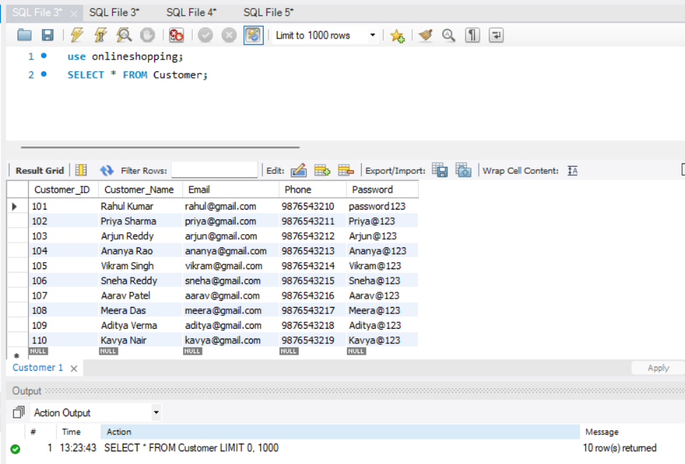

Q2. Display all categories
SELECT * FROM Category;
Output:
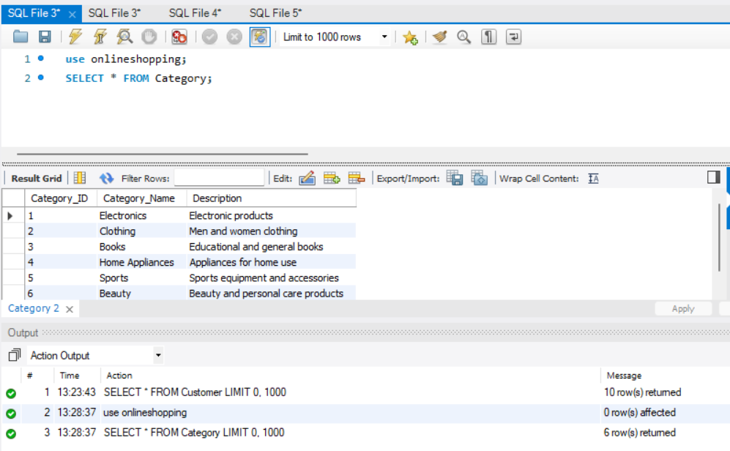
Q3. Display all products
SELECT * FROM Product;
Output:
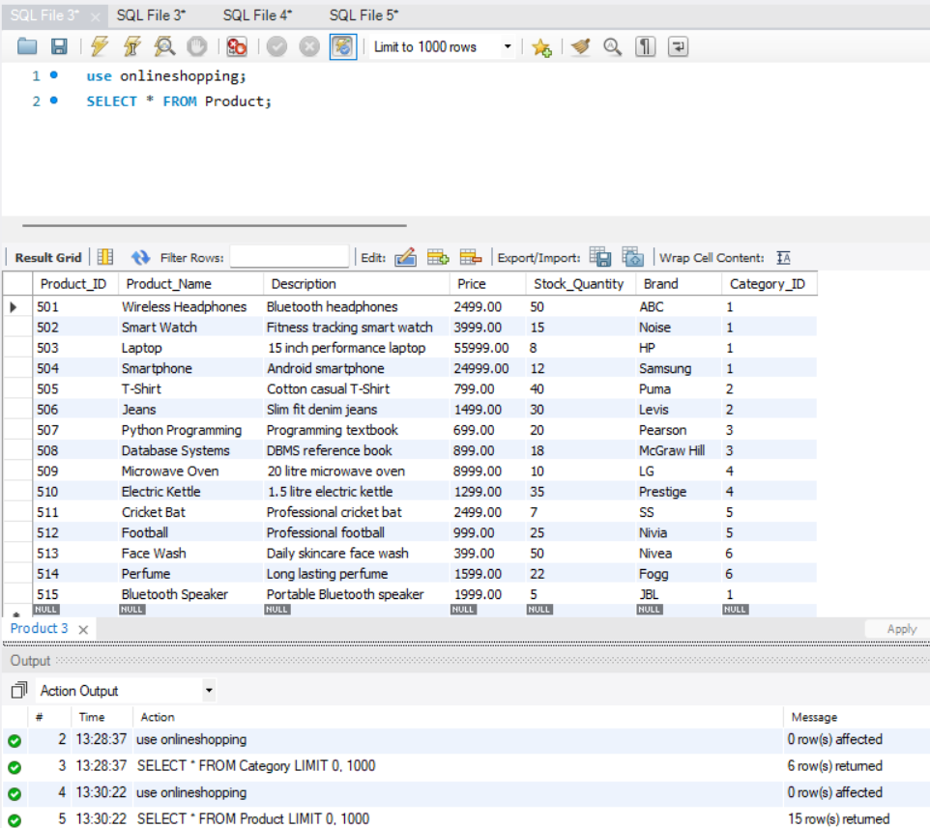
Q4. Display products costing more than ₹1000
SELECT Product_Name, Price
FROM Product
WHERE Price > 1000;
Output:
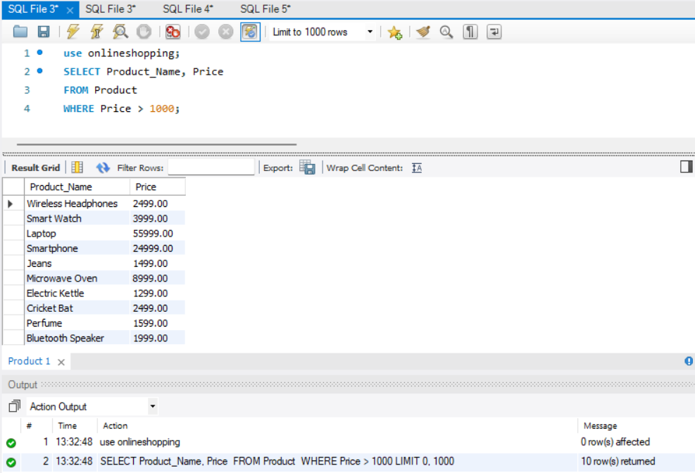

Q5. Display products category-wise
SELECT p.Product_Name, c.Category_Name
FROM Product p
JOIN Category c ON p.Category_ID = c.Category_ID;

Output:

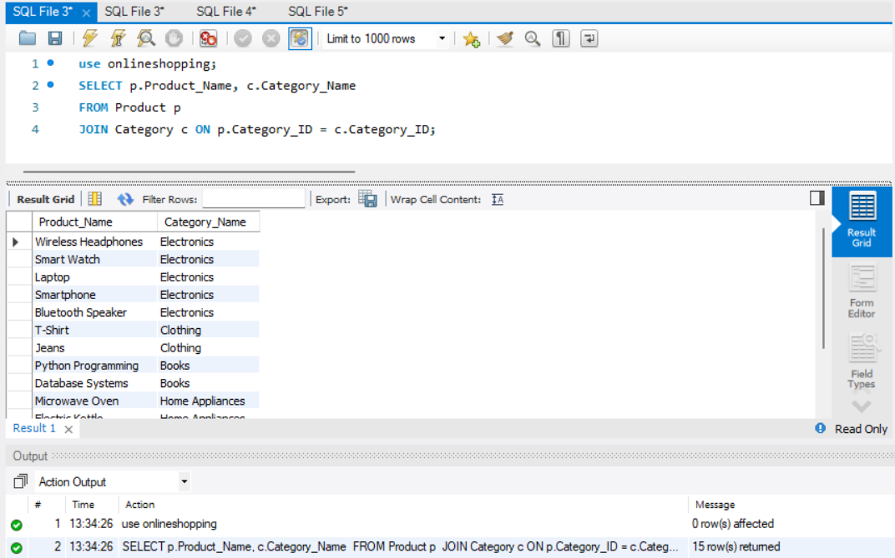

Q6. Display customer addresses
SELECT c.Customer_Name, a.City, a.State
FROM Customer c JOIN Address a ON c.Customer_ID = a.Customer_ID;
Output:
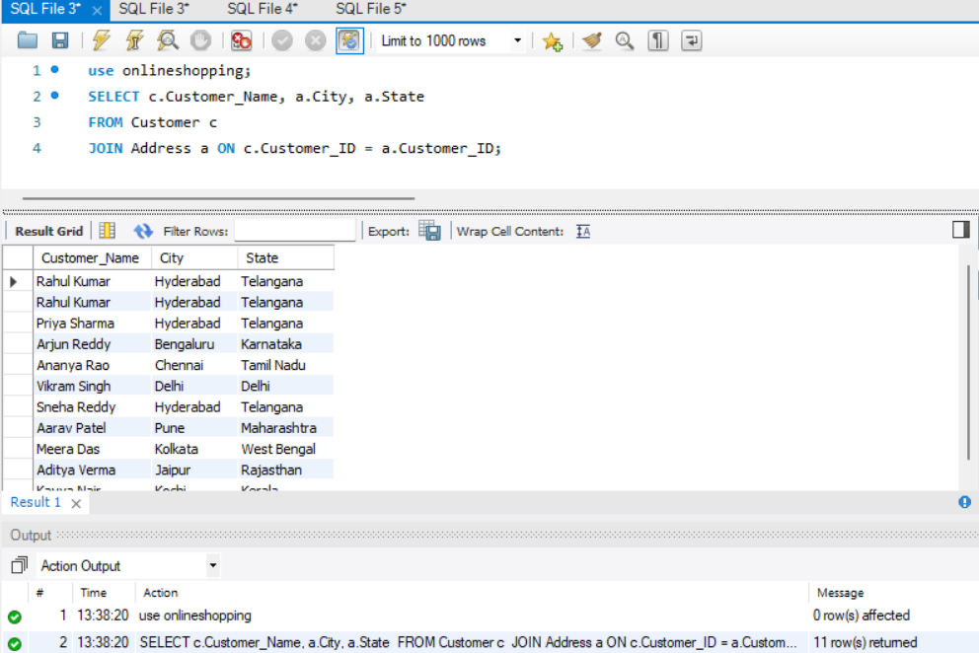
Q7. Display customer orders
SELECT c.Customer_Name, o.Order_ID, o.Order_Date, o.Total_Amount, o.Order_Status
FROM Customer c
JOIN Orders o ON c.Customer_ID = o.Customer_ID;
Output:
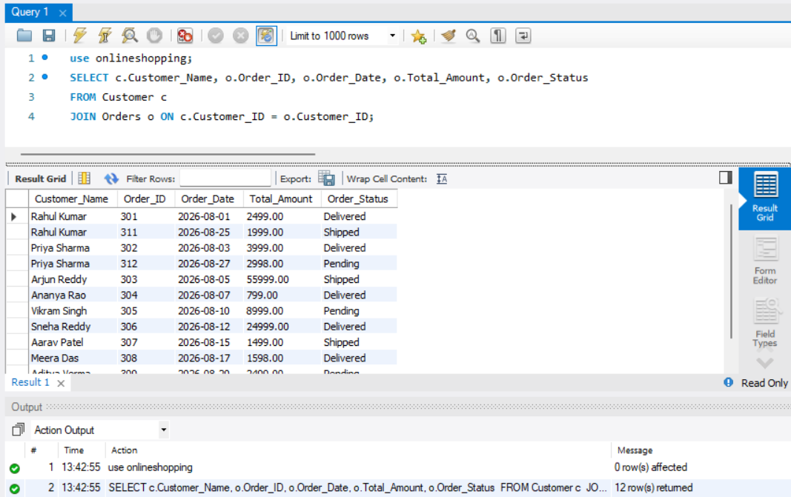

Q8. Display order payment details
SELECT o.Order_ID, p.Payment_Method, p.Amount, p.Transaction_ID
FROM Orders o
JOIN Payment p ON o.Order_ID = p.Order_ID;
Output:
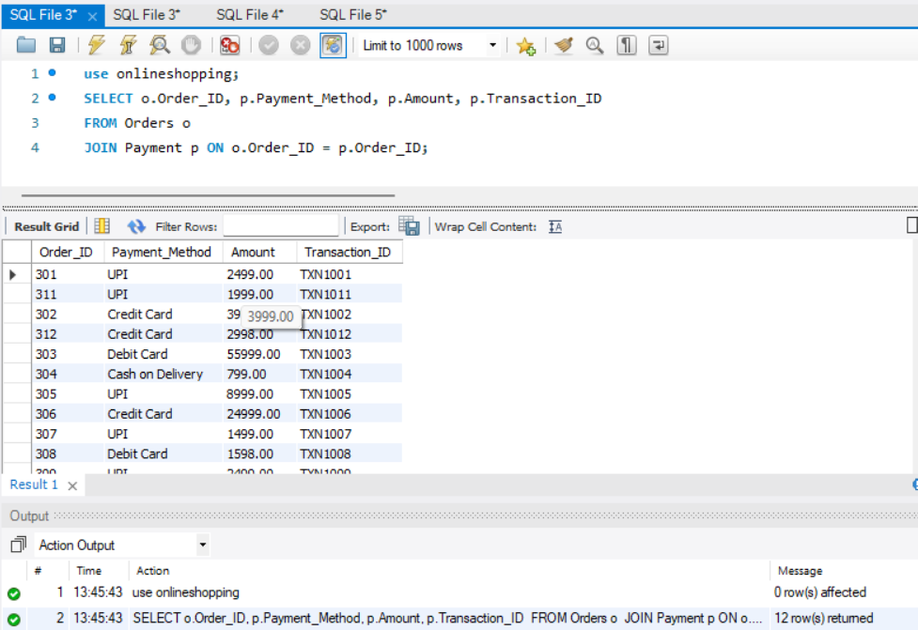

Q9. Display shipment tracking details
SELECT o.Order_ID, s.Courier_Name, s.Tracking_Number, s.Shipment_Status
FROM Orders o
JOIN Shipment s ON o.Order_ID = s.Order_ID;

Output:
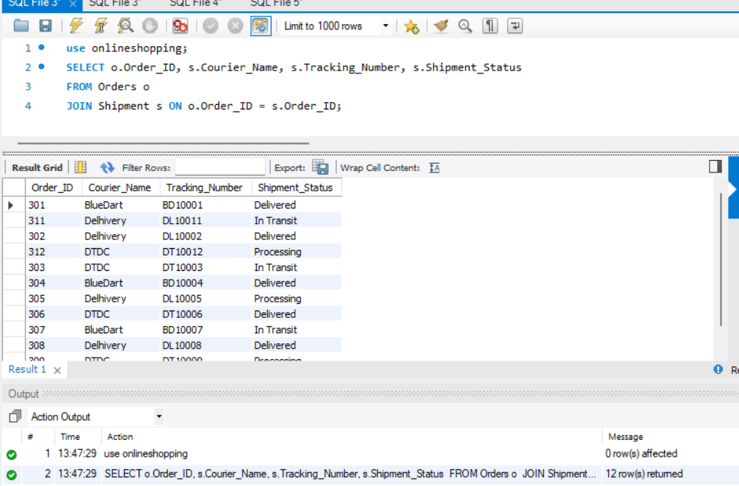

Q10. Count total customers
SELECT COUNT(*) AS Total_Customers
FROM Customer;
Output:
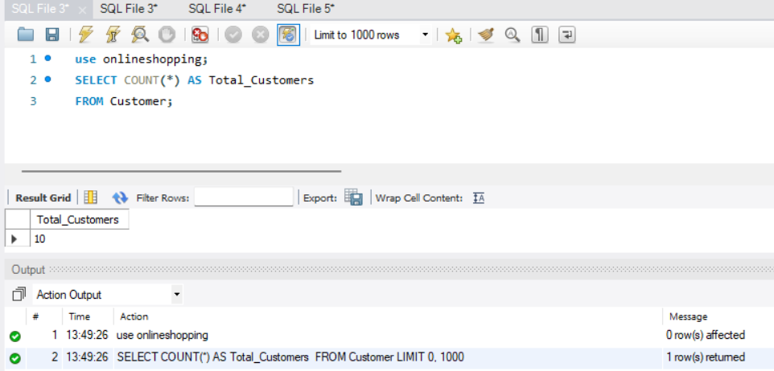
Q11. Count total products
SELECT COUNT(*) AS Total_Products
FROM Product;
Output:
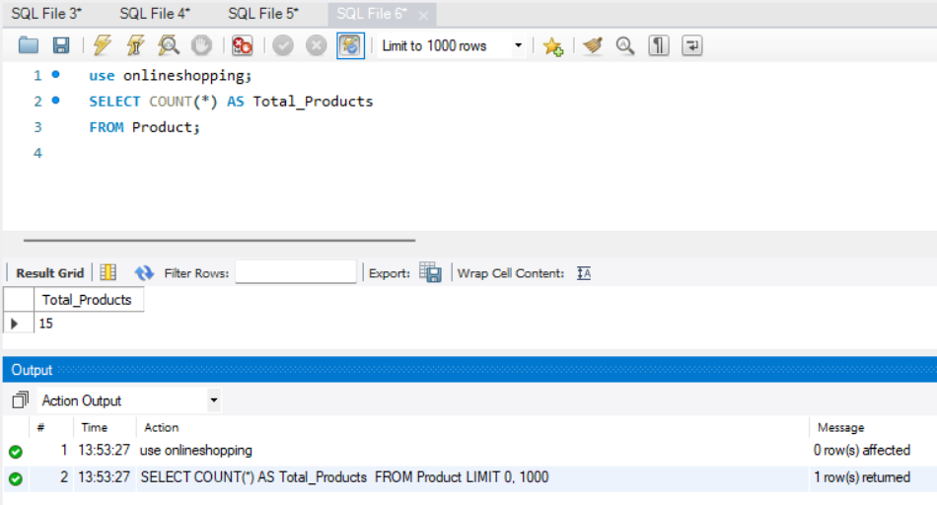
Q12. Display products with low stock
SELECT Product_Name, Stock_Quantity
FROM Product
WHERE Stock_Quantity < 10;
Output:
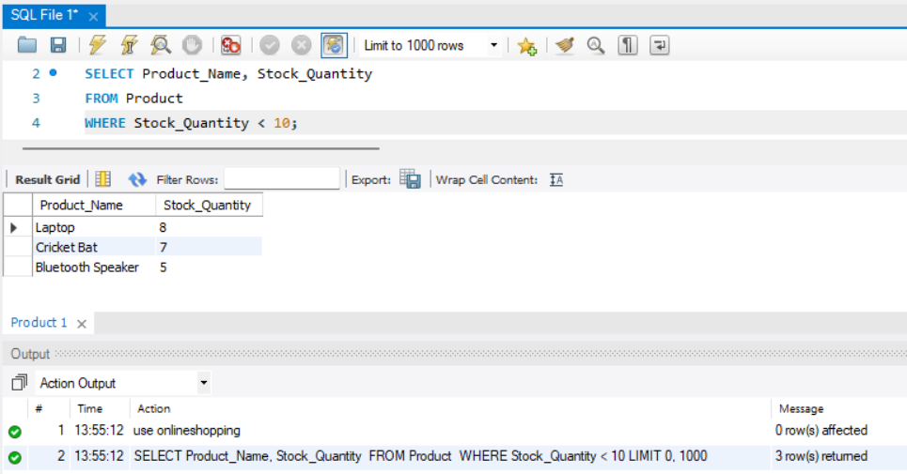
Q13. Display orders above ₹5000
SELECT *
FROM Orders
WHERE Total_Amount > 5000;
Output:
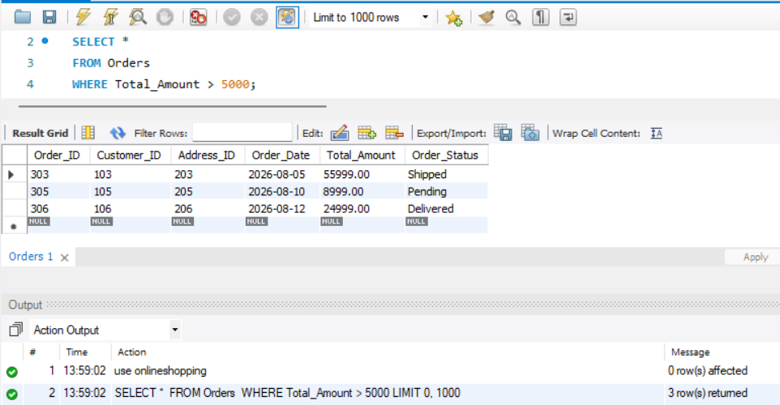

Q14. Display delivered orders
SELECT * FROM Orders WHERE Order_Status = 'Delivered';
Output:
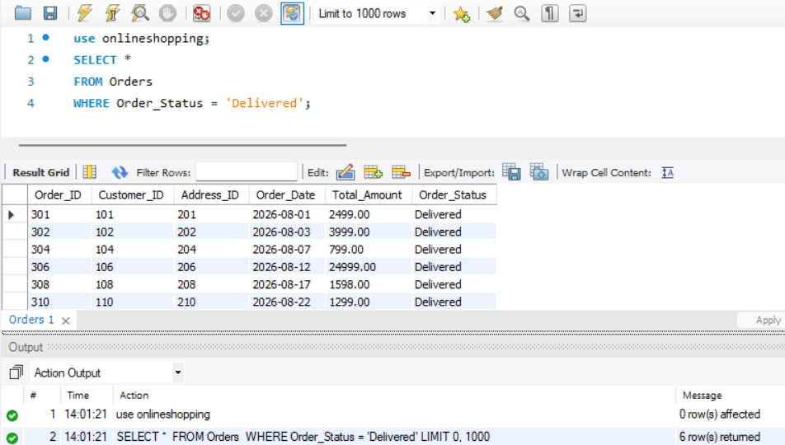
Q15. Display pending orders
SELECT * FROM Orders WHERE Order_Status = 'Pending';
Output:
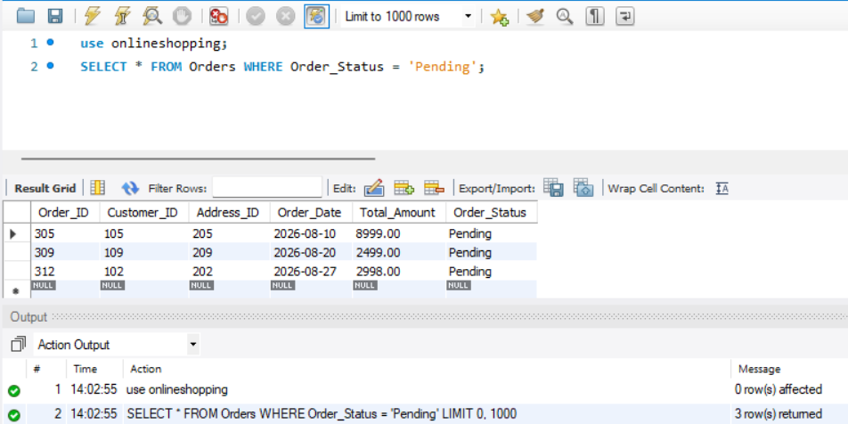

Q16. Calculate average product price
SELECT AVG(Price) AS Average_Price
FROM Product;
Output:
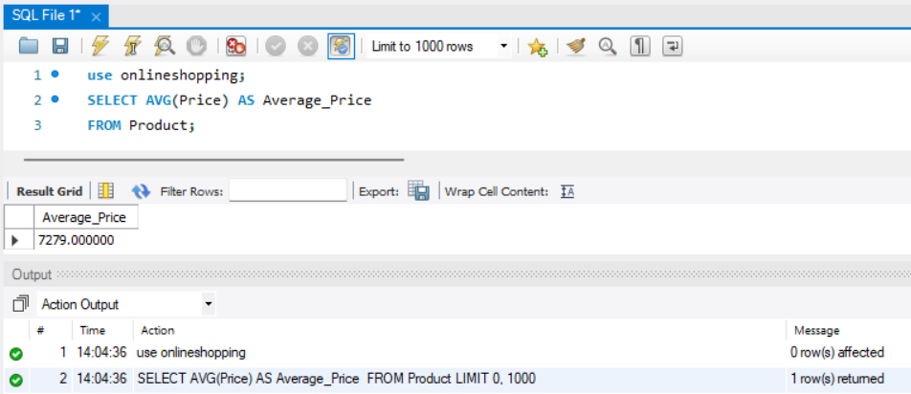
Q17. Find maximum product price
SELECT MAX(Price) AS Maximum_Price
FROM Product;
Output:
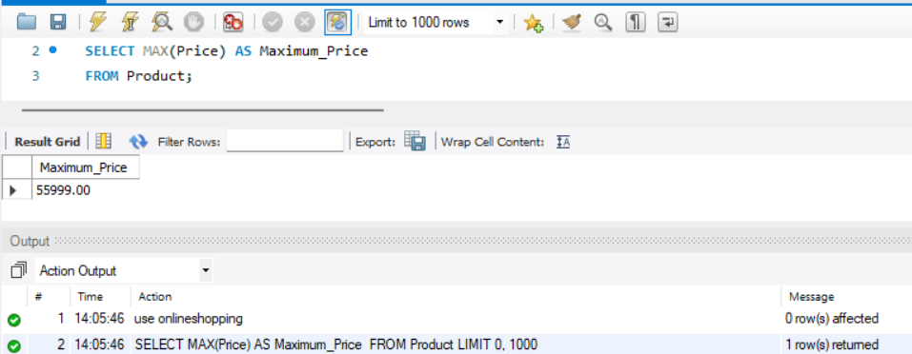

Q18. Find minimum product price
SELECT MIN(Price) AS Minimum_Price FROM Product;
Output:
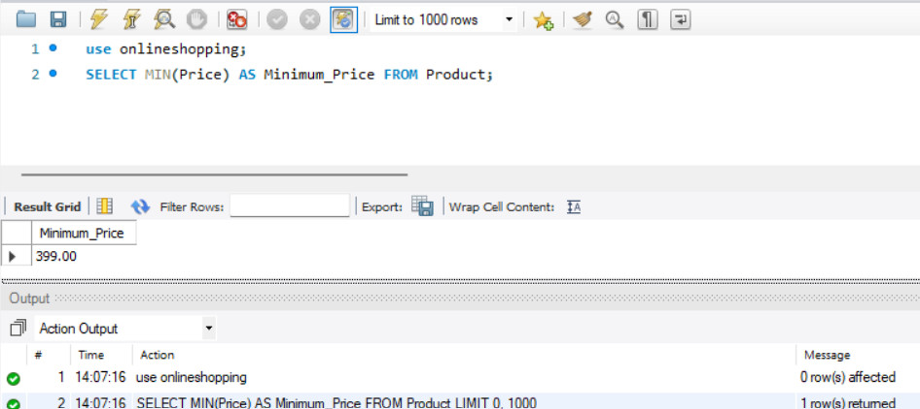

Q19. Count products category-wise
SELECT Category_ID, COUNT(*) AS Product_Count
FROM Product GROUP BY Category_ID;

Output:
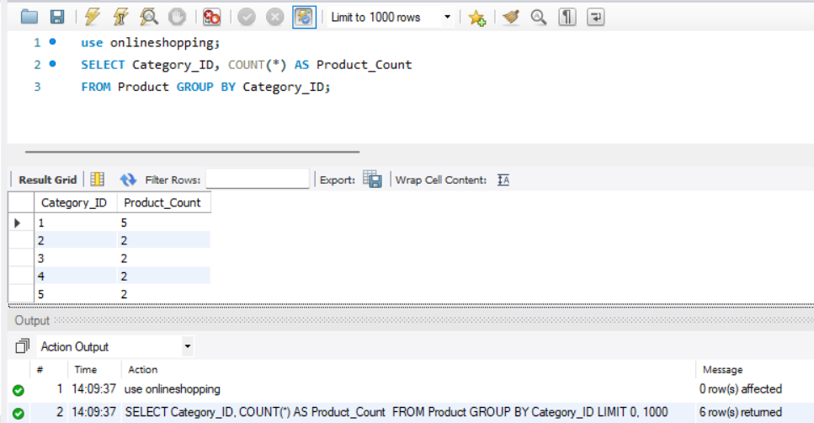
Q20. Display products of a particular brand
SELECT * FROM Product WHERE Brand = 'ABC';
Output: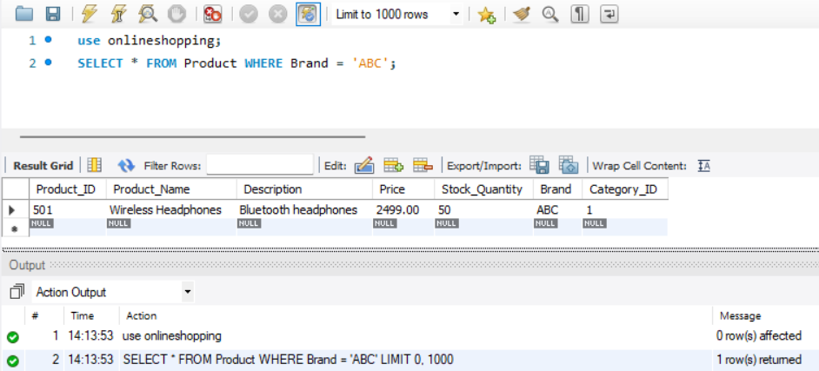
Q21. Display customers whose names start with A
SELECT * FROM Customer WHERE Customer_Name LIKE 'A%';
Output:
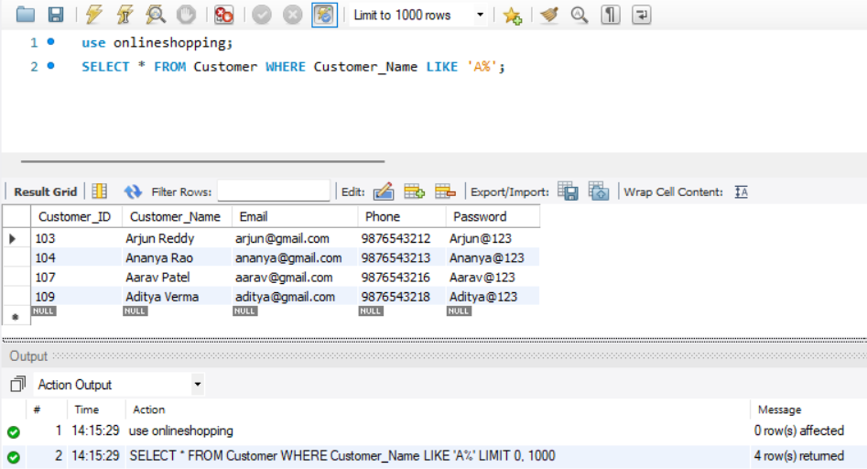
Q22. Display reviews with rating 5
SELECT * FROM Review WHERE Rating = 5;
Output:
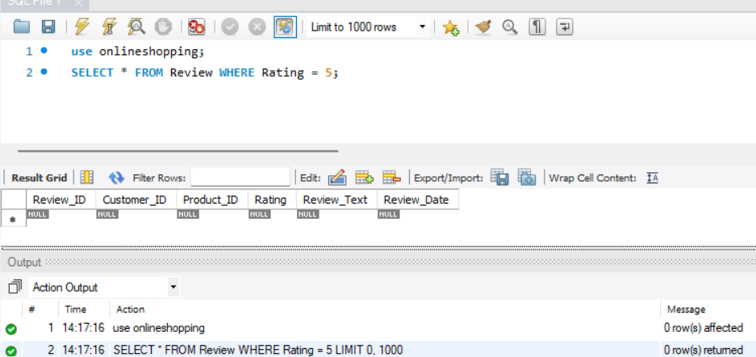

Q23. Find average product rating
SELECT Product_ID, AVG(Rating) AS Average_Rating FROM Review GROUP BY Product_ID;
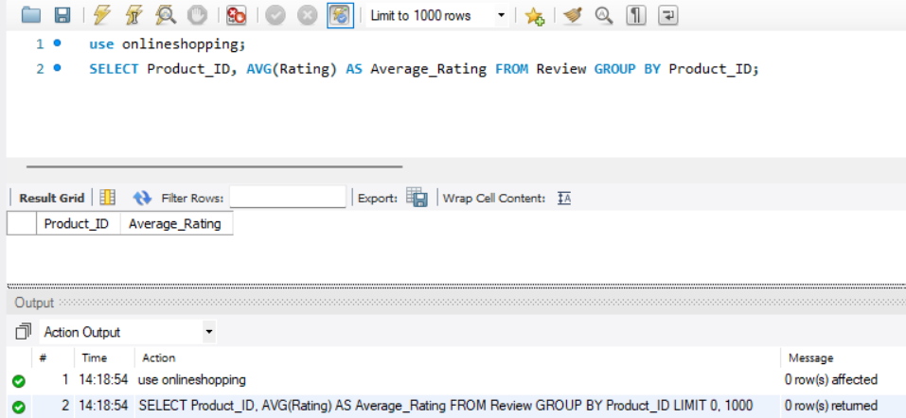
Q24. Count orders for each customer
SELECT Customer_ID, COUNT(*) AS Order_Count FROM Orders GROUP BY Customer_ID;
Output:
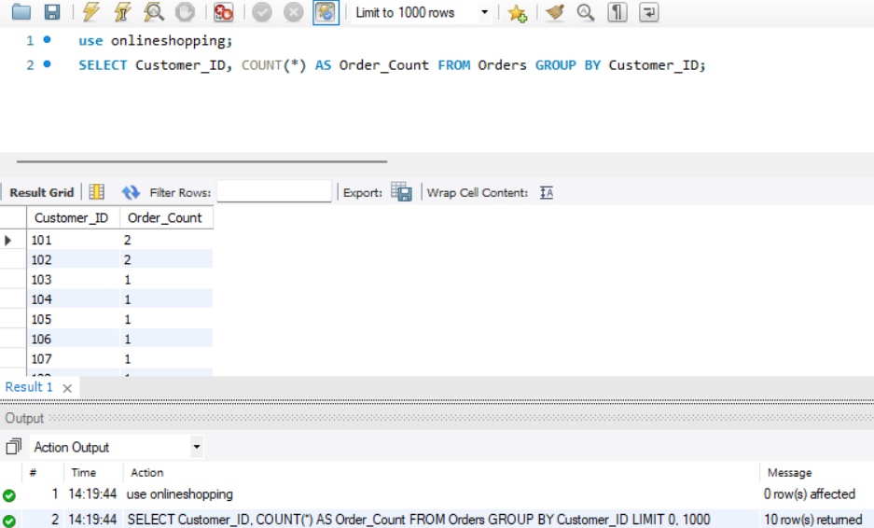
Q25. Display orders with customer names
SELECT c.Customer_Name, o.Order_ID, o.Total_Amount
FROM Customer c JOIN Orders o ON c.Customer_ID = o.Customer_ID;
Output:
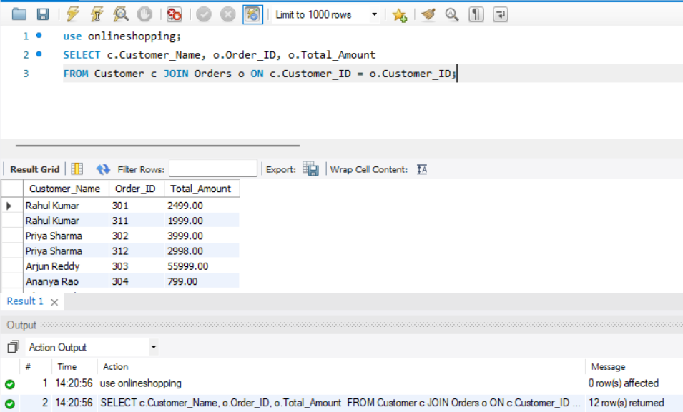
Q26. Display orders and shipment status
SELECT o.Order_ID, o.Order_Status, s.Shipment_Status
FROM Orders o JOIN Shipment s ON o.Order_ID = s.Order_ID;
Output:
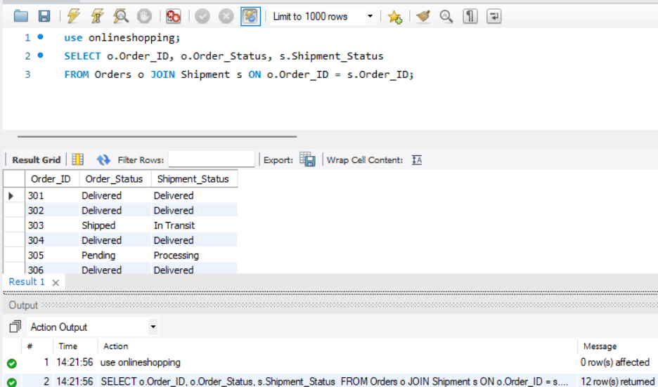
Q27. Display payment details above ₹1000
SELECT * FROM Payment WHERE Amount > 1000;
Output:
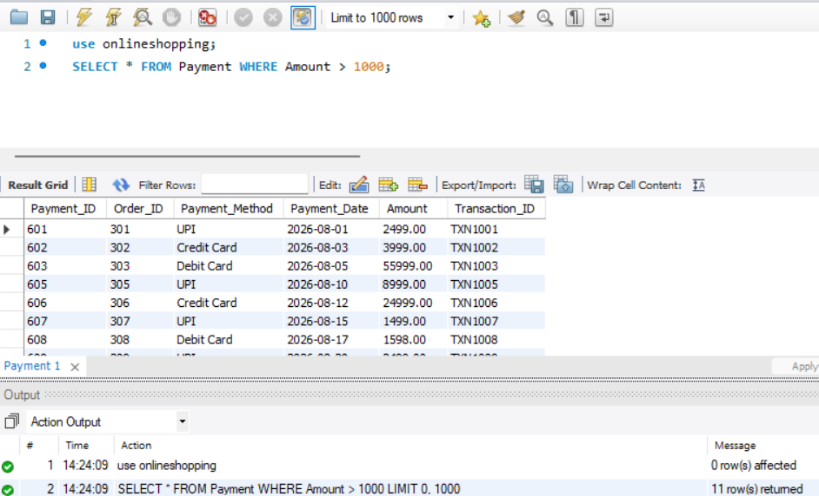
Q28. Display products having stock
SELECT Product_Name, Stock_Quantity FROM Product WHERE Stock_Quantity > 0;
Output:
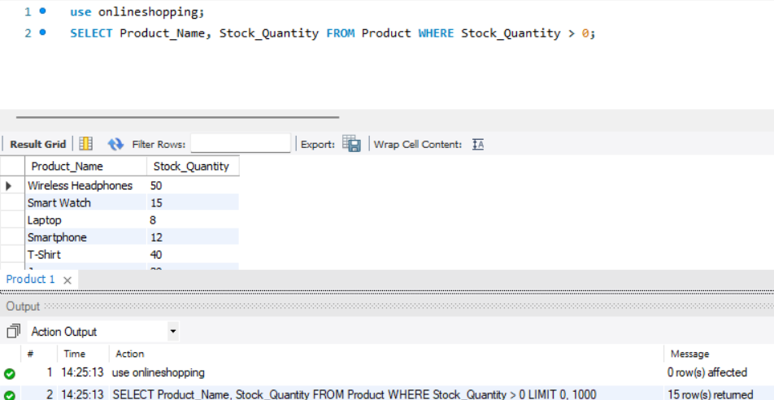

Q39. Display products containing a keyword
SELECT * FROM Product WHERE UPPER(Product_Name) LIKE '%PHONE%';
Output:
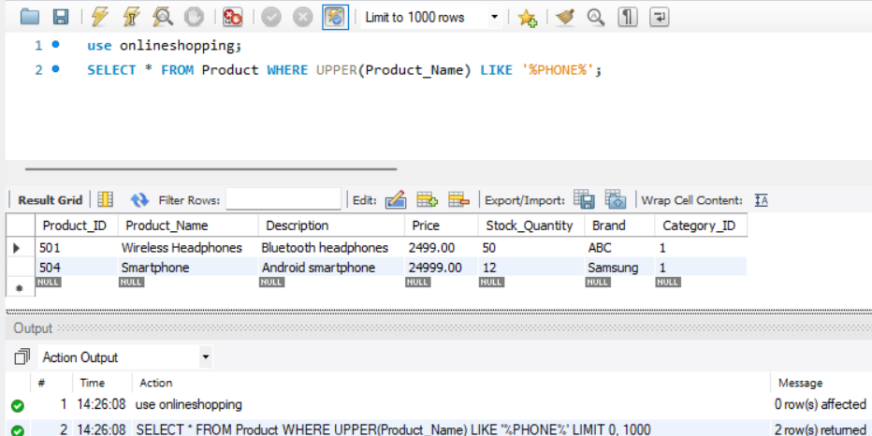
11. CONCLUSION
The Online Shopping System provides a structured database solution for managing the major activities of an online shopping platform. The system organizes information related to customers, categories, products, addresses, carts, orders, payments, shipments, and reviews into separate but related tables. The use of primary keys and foreign keys helps establish relationships between entities and maintain referential integrity. The relational schema provides an organized representation of the database structure. Normalization helps reduce data redundancy and update anomalies by separating information into appropriate relations. SQL operations can be used to insert, retrieve, update, delete, filter, join, and aggregate data from the database. The project therefore provides a suitable DBMS foundation for an online shopping application and can be extended with additional e-commerce functionality.

12. FUTURE ENHANCEMENTS
1. Inventory Management
Real-time stock management can be implemented to automatically update product availability after orders.
2. Wishlist Management
Customers can save products for future purchases.
3. Recommendation System
A recommendation module can suggest products based on customer purchase history and product preferences.
4. Discount and Coupon Management
The system can be extended to support discount codes, coupons and promotional offers.
5. Return and Refund Management
A separate module can manage product returns and refund processing.
6. Multiple Payment Gateways
The system can support different online payment methods.
7. Advanced Search
Customers can search and filter products based on category, brand, price and rating.
8. Analytics Dashboard
Administrators can view sales, customer, product and inventory analytics.
9. Role-Based Access Control
Different permissions can be provided to customers, administrators, sellers and delivery personnel.
10. Backup and Recovery
Automated database backup and recovery mechanisms can be implemented to protect important data.

REFERENCES
Korth, H. F., Silberschatz, A., and Sudarshan, S., Database System Concepts, McGraw Hill.
Elmasri, R. and Navathe, S. B., Fundamentals of Database Systems, Pearson.
Connolly, T. and Begg, C., Database Systems: A Practical Approach to Design, Implementation, and Management, Pearson.
Coronel, C. and Morris, S., Database Systems: Design, Implementation, & Management, Cengage Learning.
Ramakrishnan, R. and Gehrke, J., Database Management Systems, McGraw Hill.

